ASSESSMENT-2

1.Create a P-T-S VPN and attach VM to it.

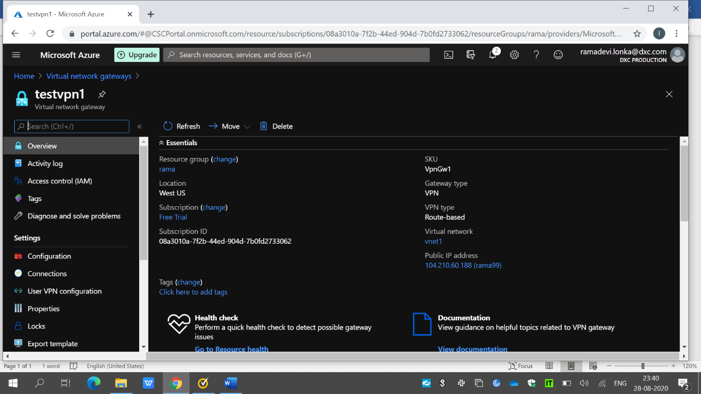

Here I have created a VPN named testvpn1 using virtual network vnet1.

Using vpn configuration,point to site vpn is configured.

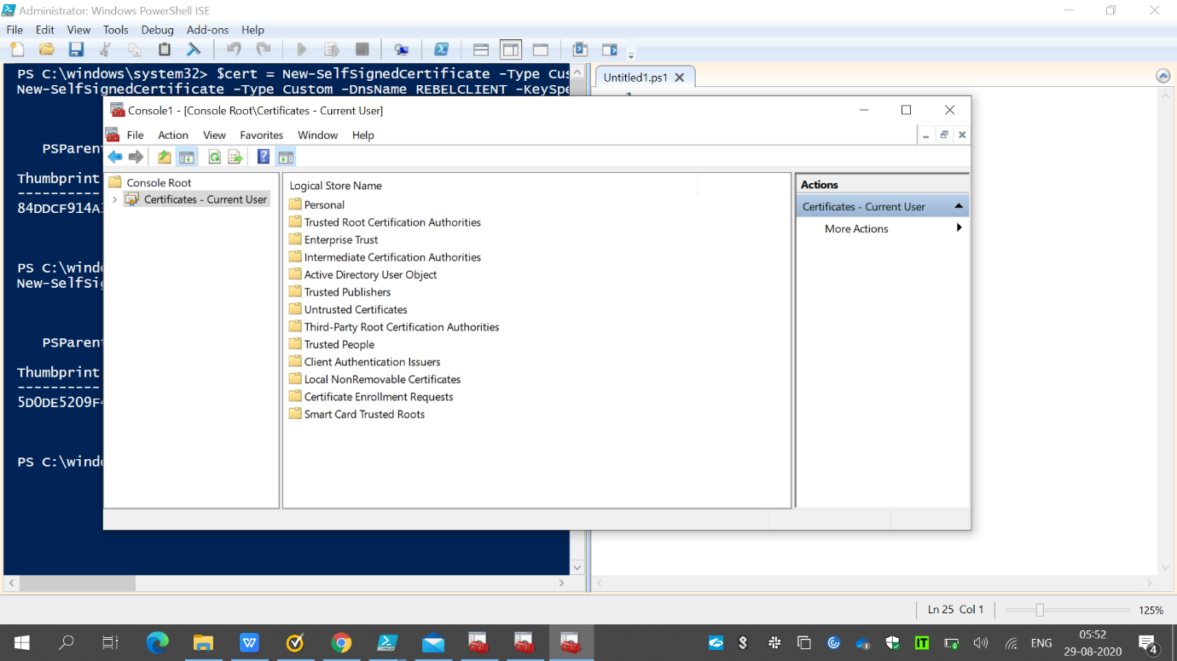

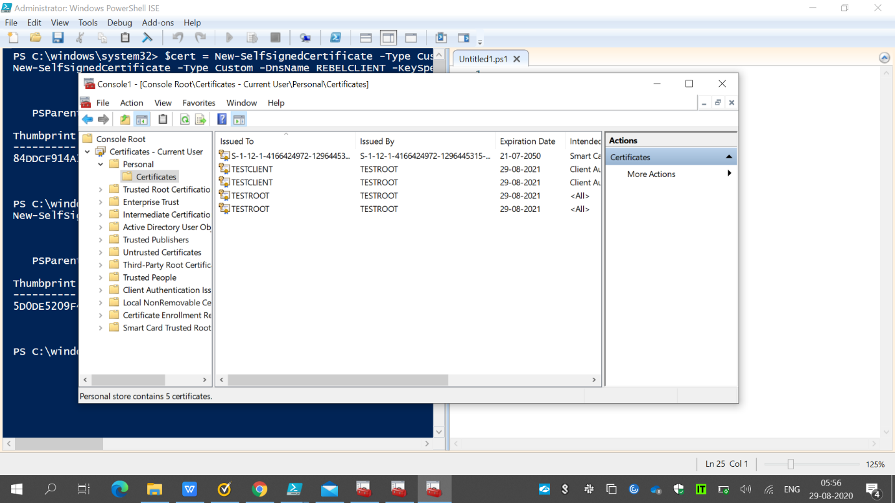

The above shows the creation of client and root certificates using powershell.

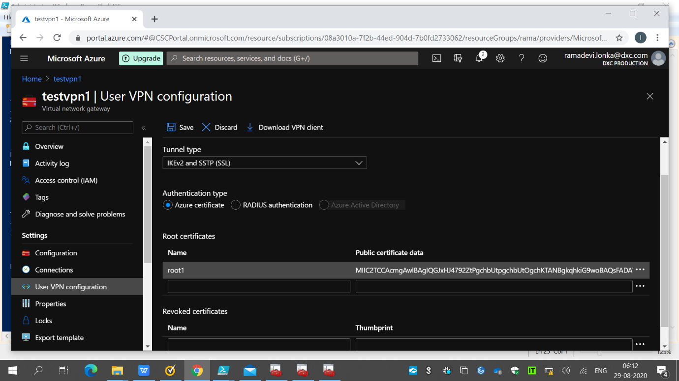

Here I have obtained the root certificate data.

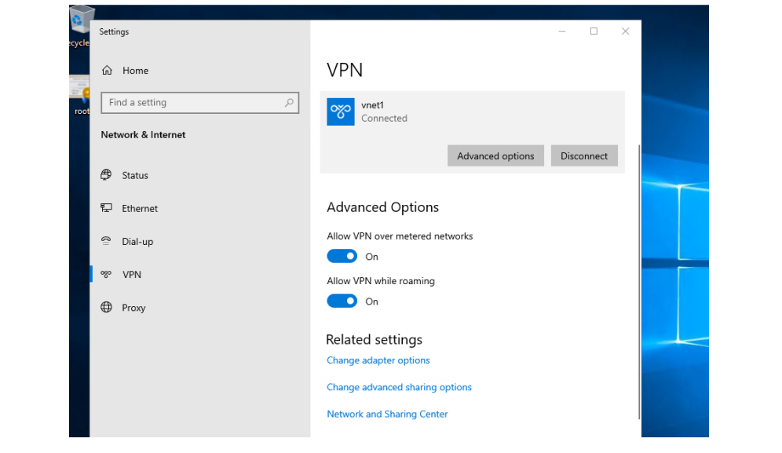

2. create two web applications in west us and central Us then attach to the traffic manager with Priority routing method.

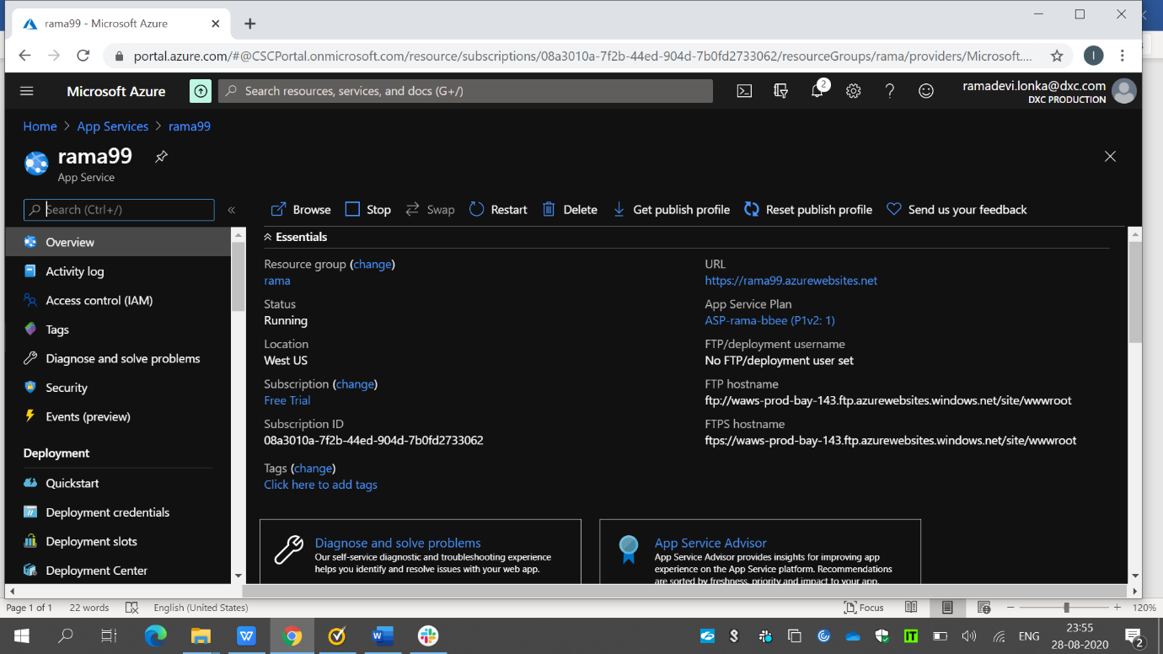

The above snap shows a web application named rama99 in westus location.

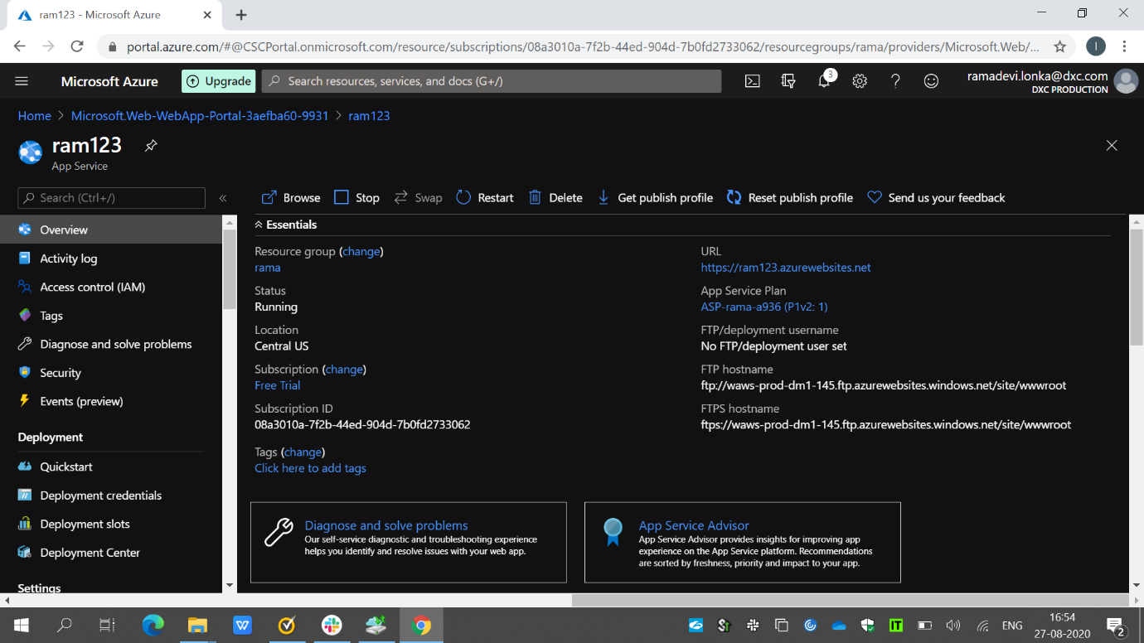

Here I have created a web application named ram123 in Central US location.

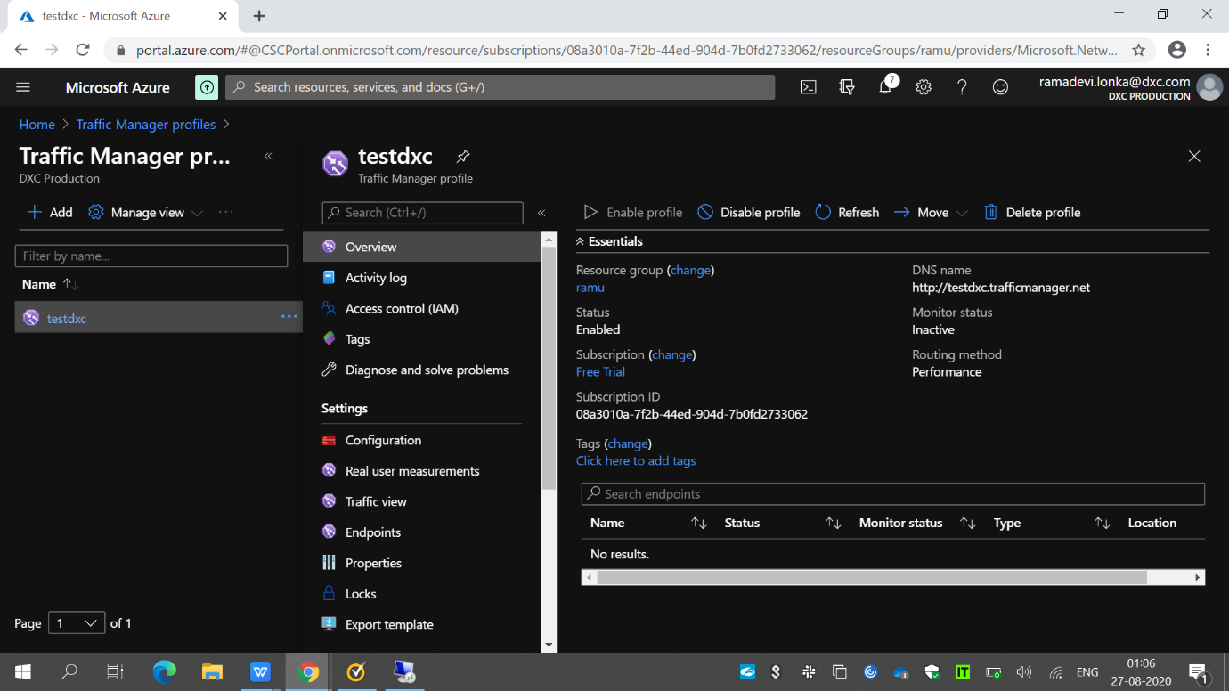

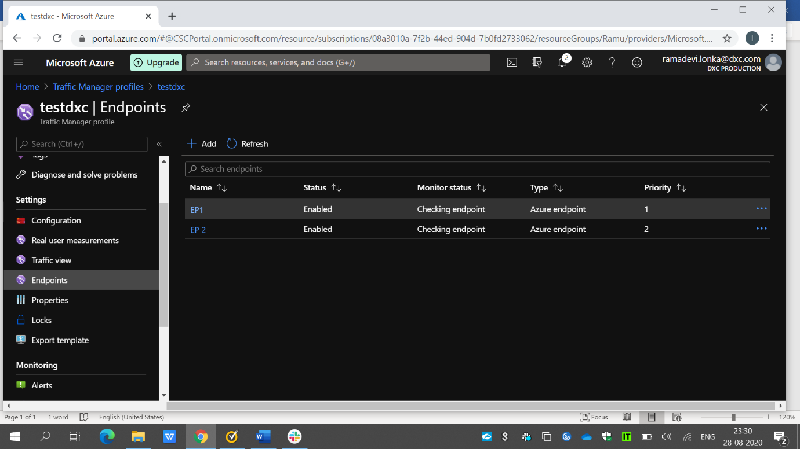

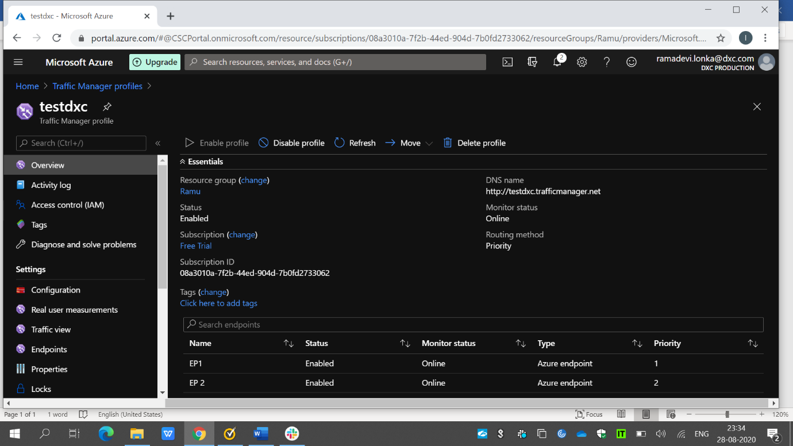

And now I have created a traffic manager profile named testdxc and then attached these 2 webapps using priority routing method.

3.Create a Windows server with AD installed and integrate with Azure AD.

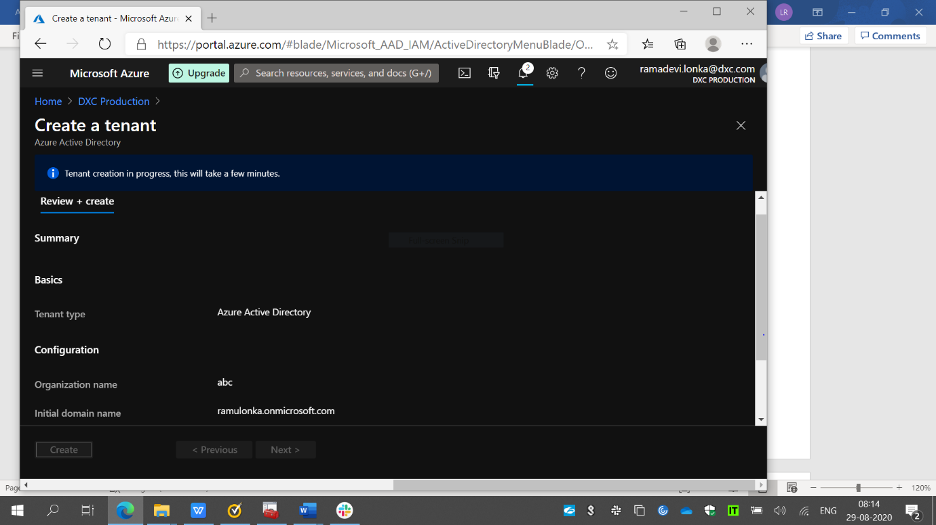

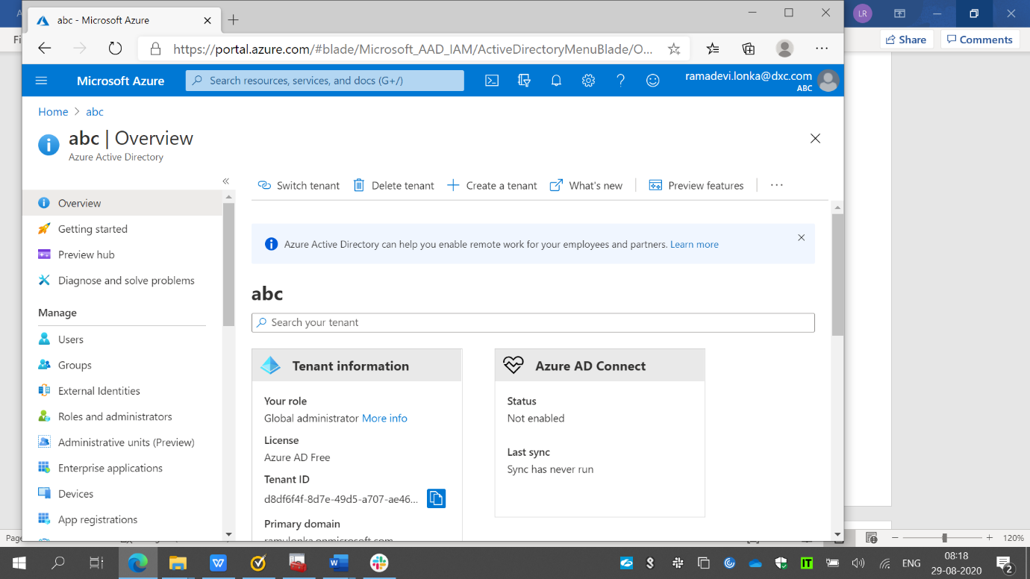

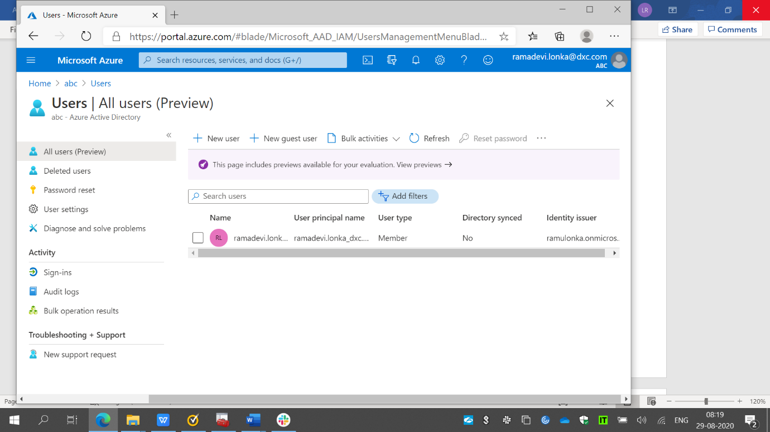

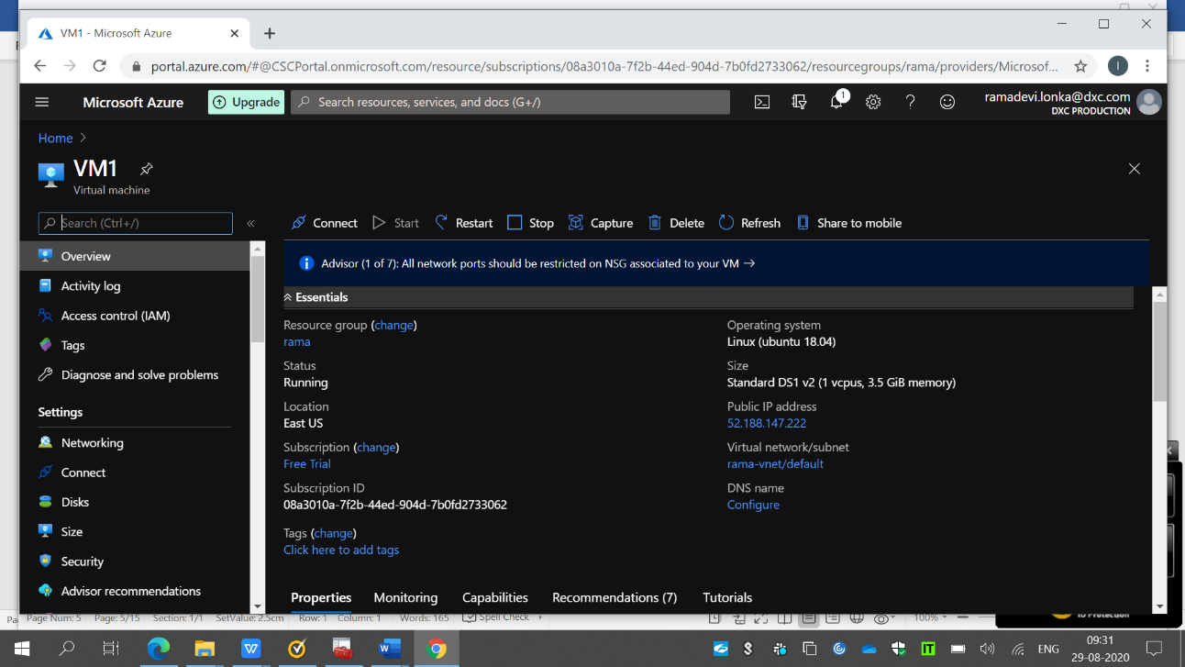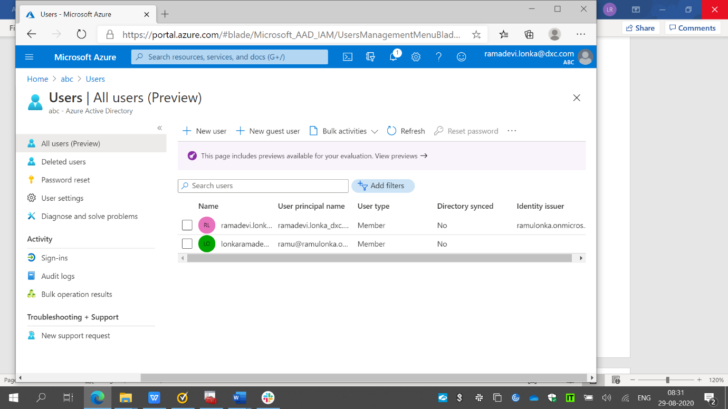  
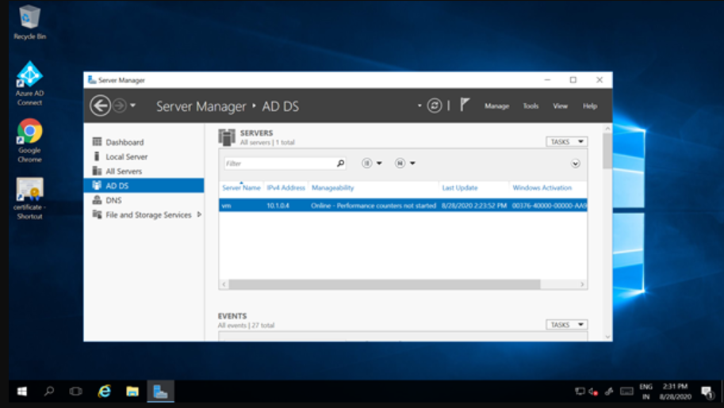

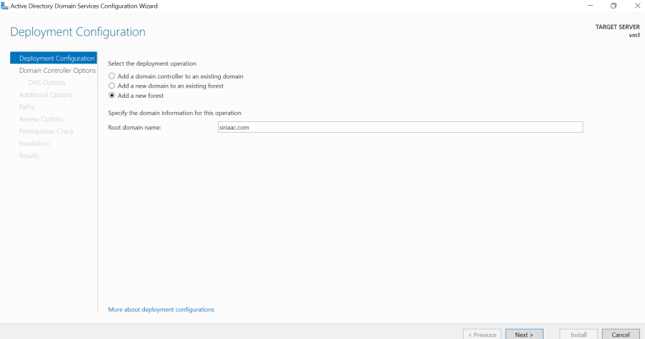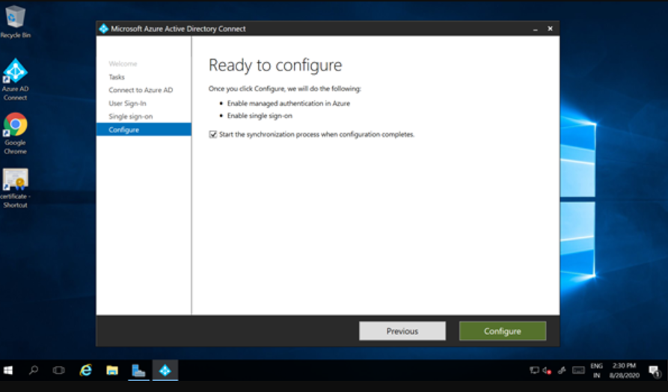

4.Configure a Backup to the VM installed AD.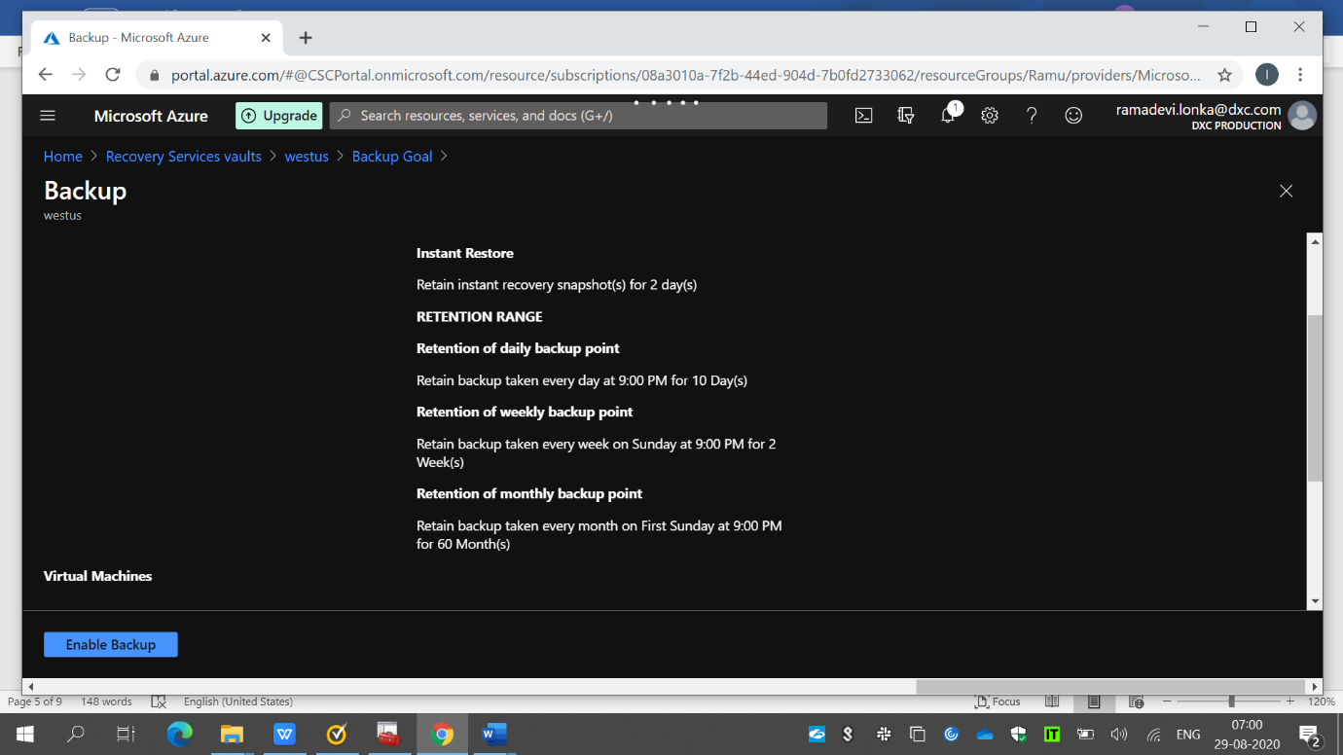

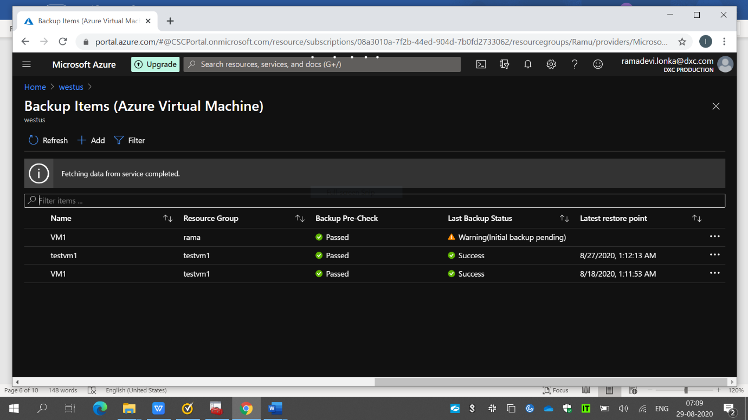

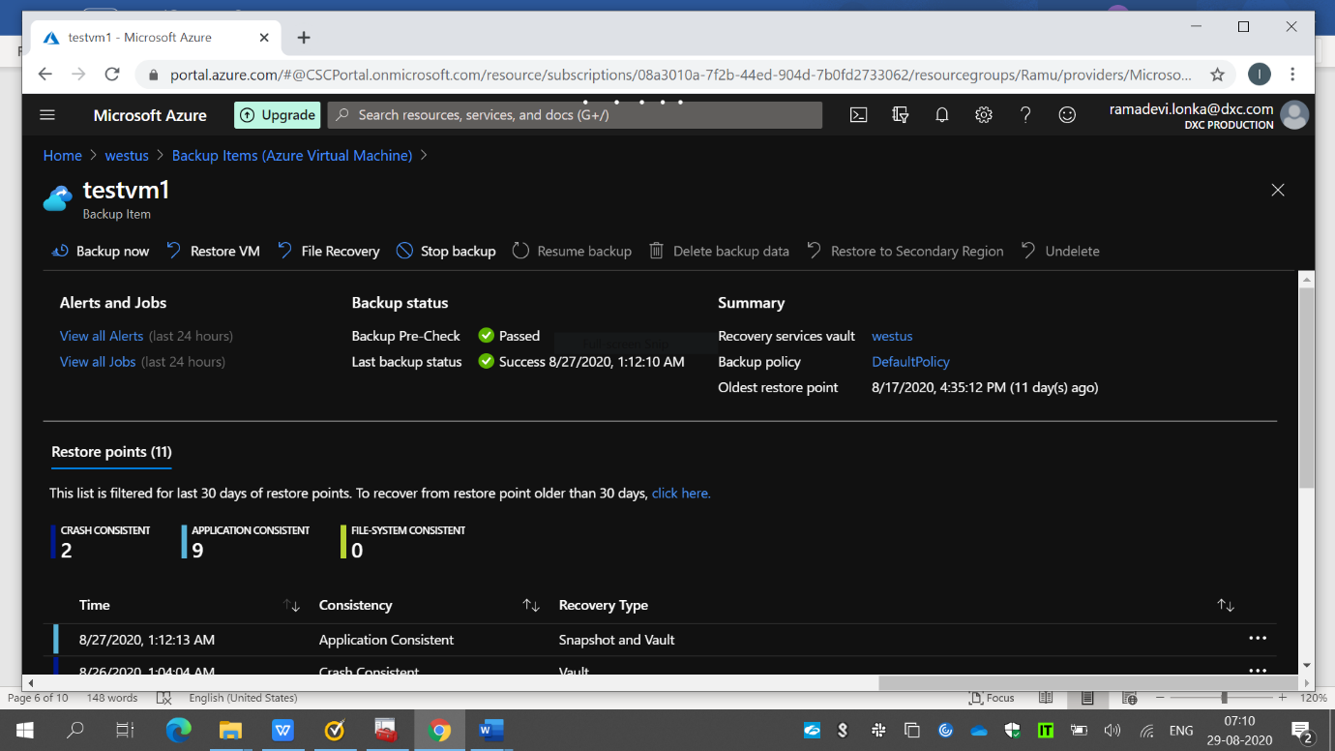

Here I have enabled the backup for the VM’S.

4.Configure alerts for VM.

Here I have configured the alerts for VM named VM1 under resource group rama.

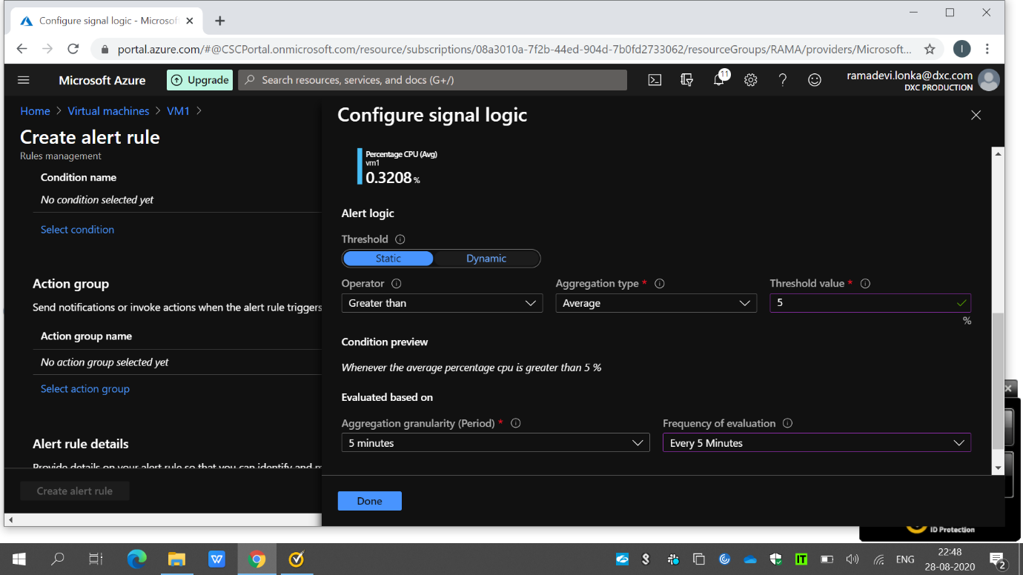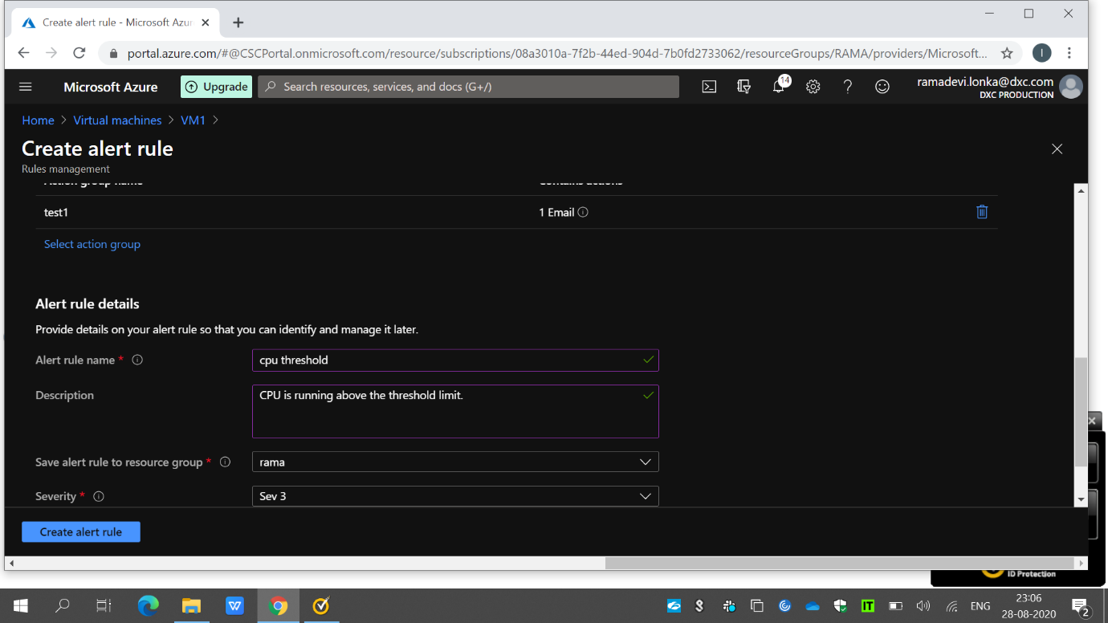

Here I have created rule for CPU threshold.When the CPU threshold value is greater than 5%,the admin will be notified by an email.

6.Apply any security policy to the subscription.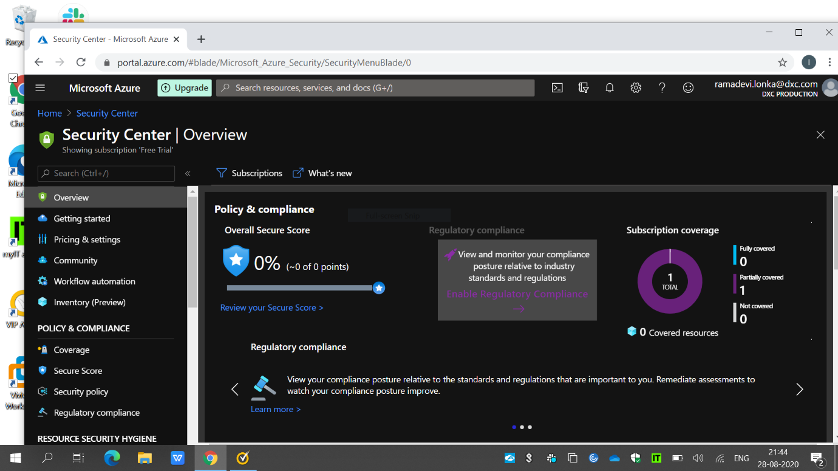In my free subscription security policy ,I have created policy that VM BACKUP POLICY.

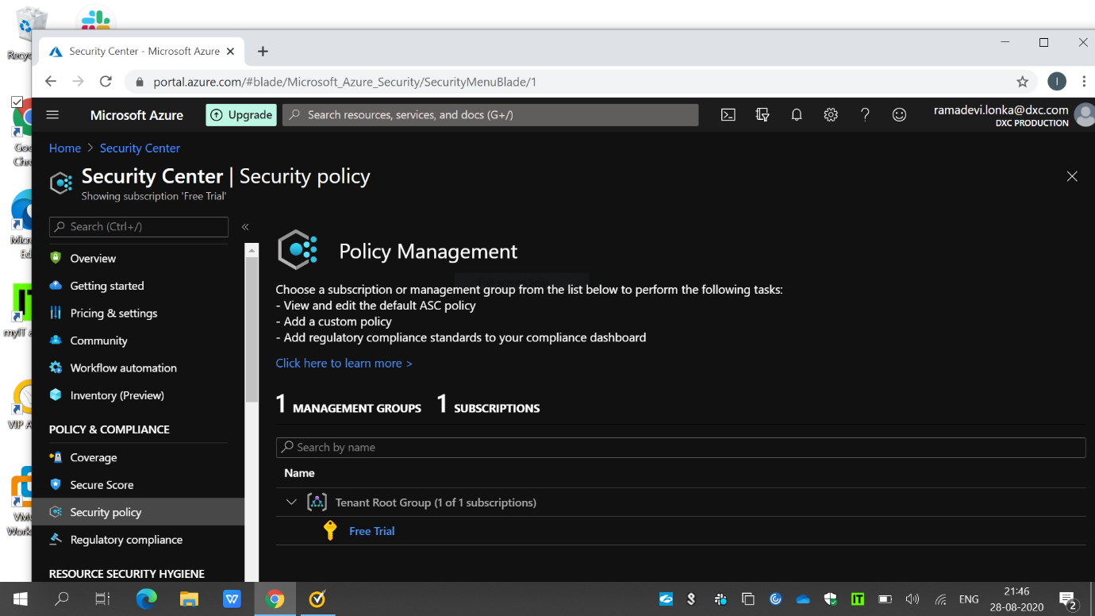 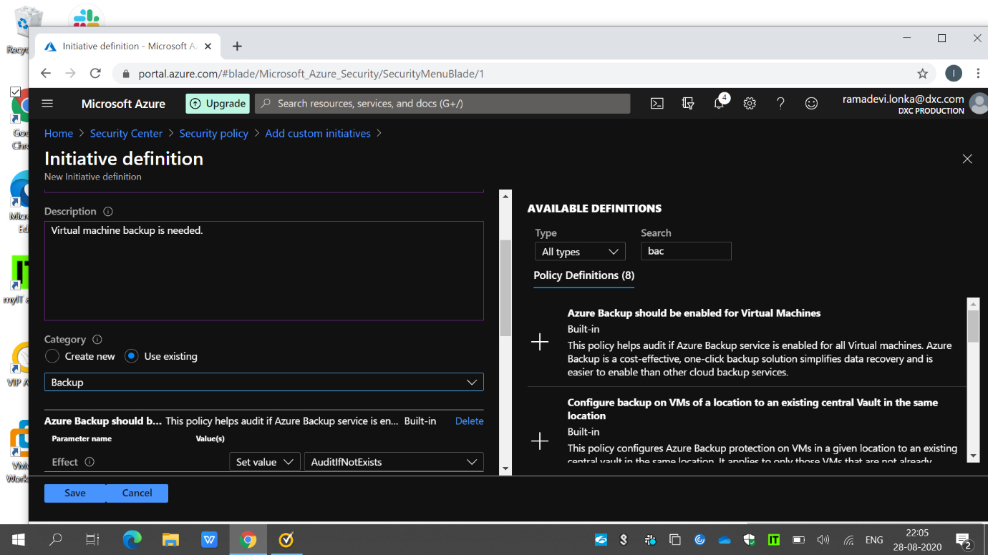Here security policy>freetrail>intiative definition and then depending upon our required policy we have to create the policy ..here the one is VM BACKUP POLICY.

7.Create a SQL server with database installed in the elastic pool.

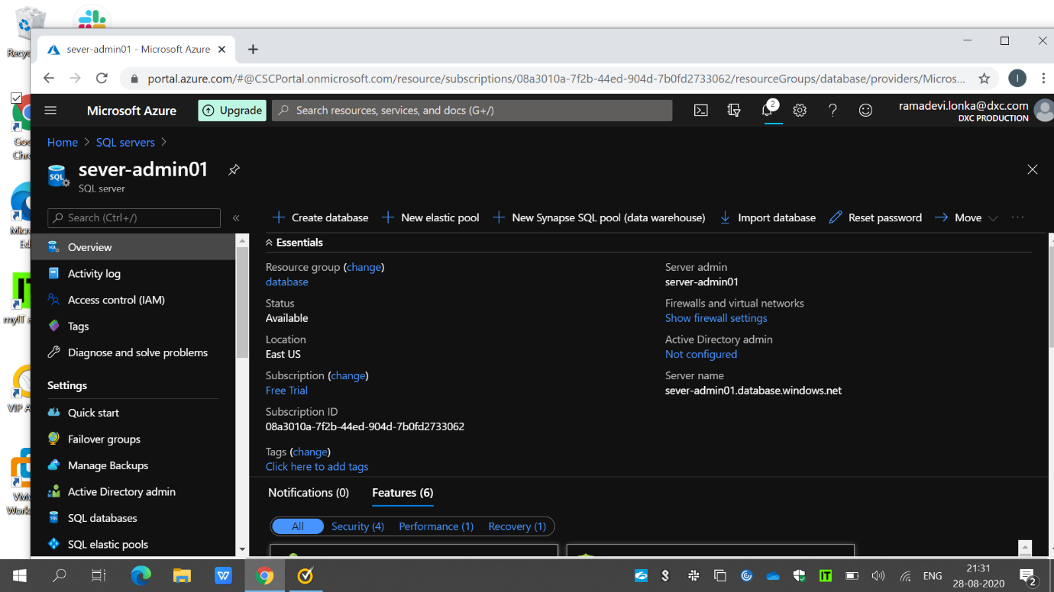

Here,in the above snip I created a SQL server named server-admin under resource group database.

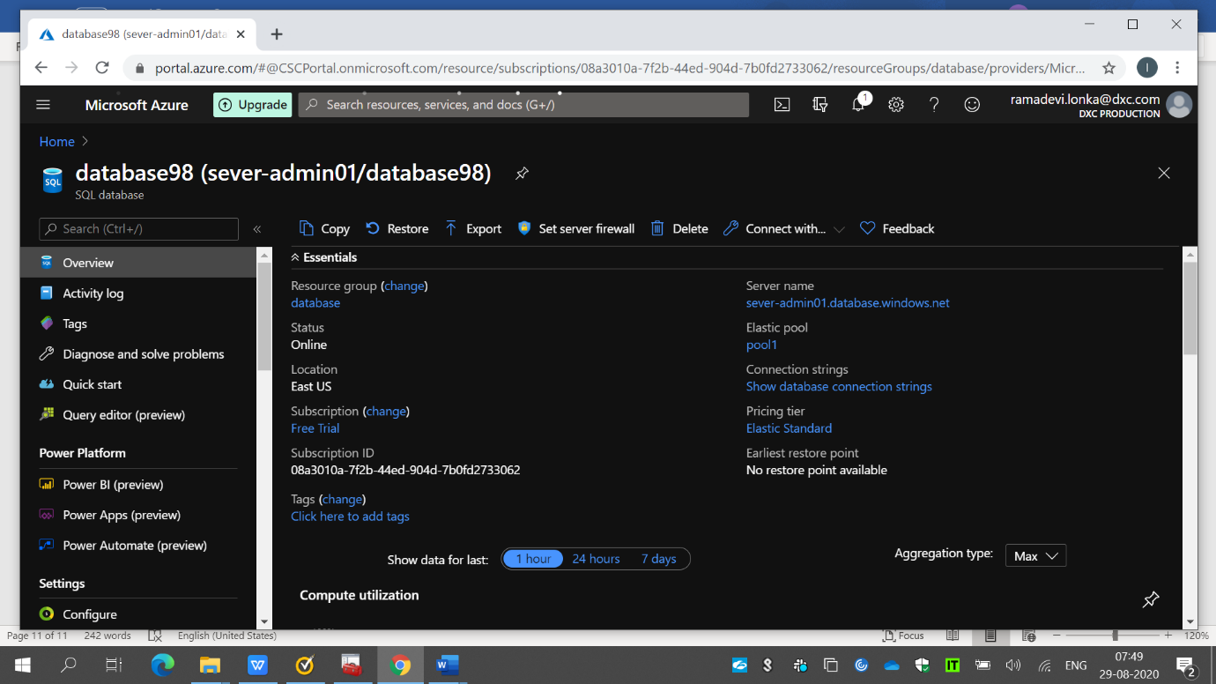

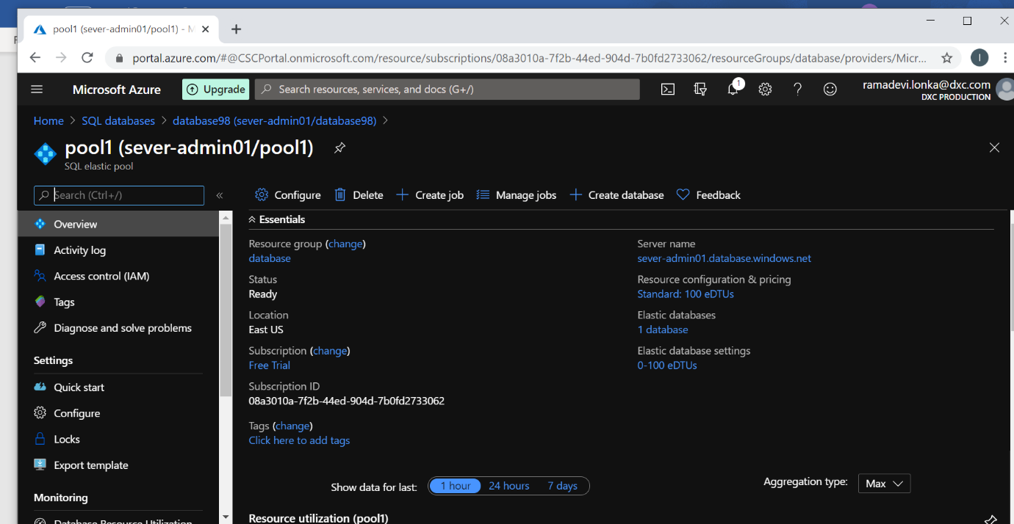

Here we are having a database named database98 under resource database with elastic pool named pool1.